Pre requirements:
JAVA 17 or 21 version
Download link for java 21: Java Archive Downloads - Java SE 17.0.12 and earlier
Url:https://www.oracle.com/java/technologies/javase/jdk17-archive-downloads.html

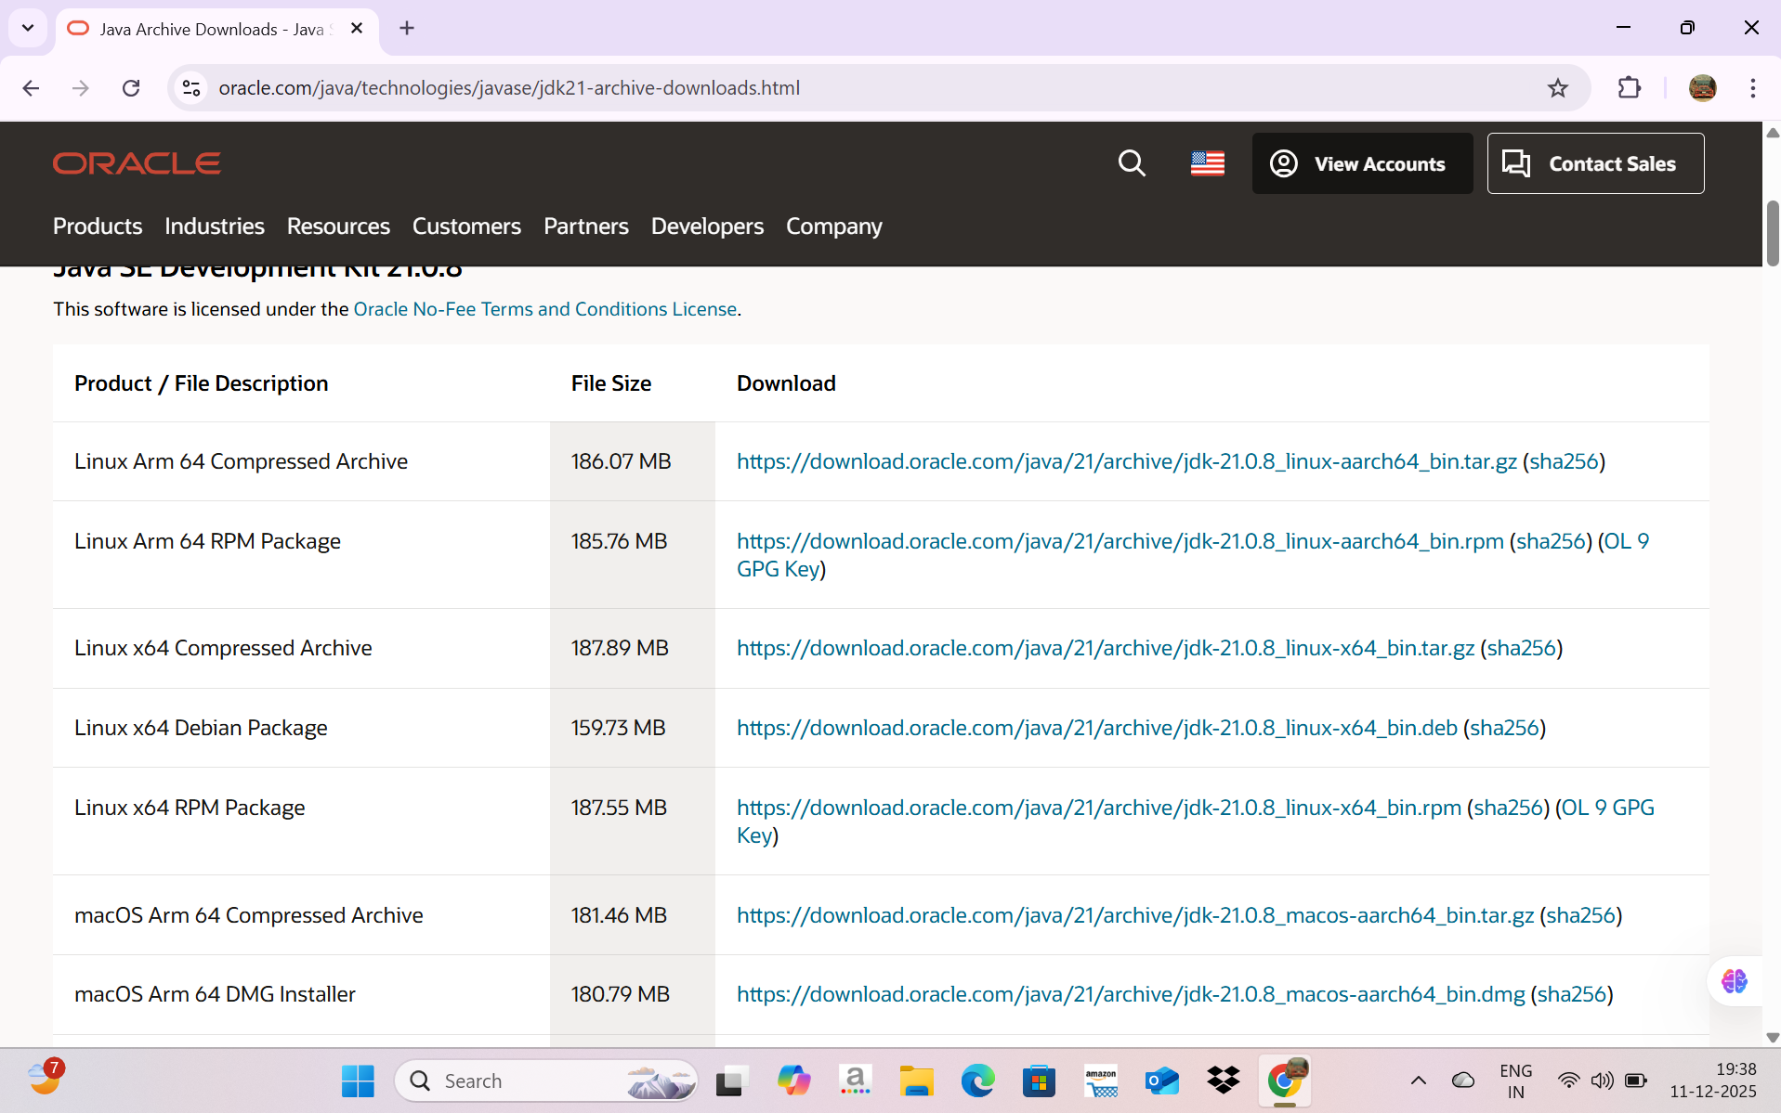

Download and install windows x64 MSI installer

Url for spring tools suite:Spring | Tools
https://spring.io/tools

Choose spring tools for eclipse

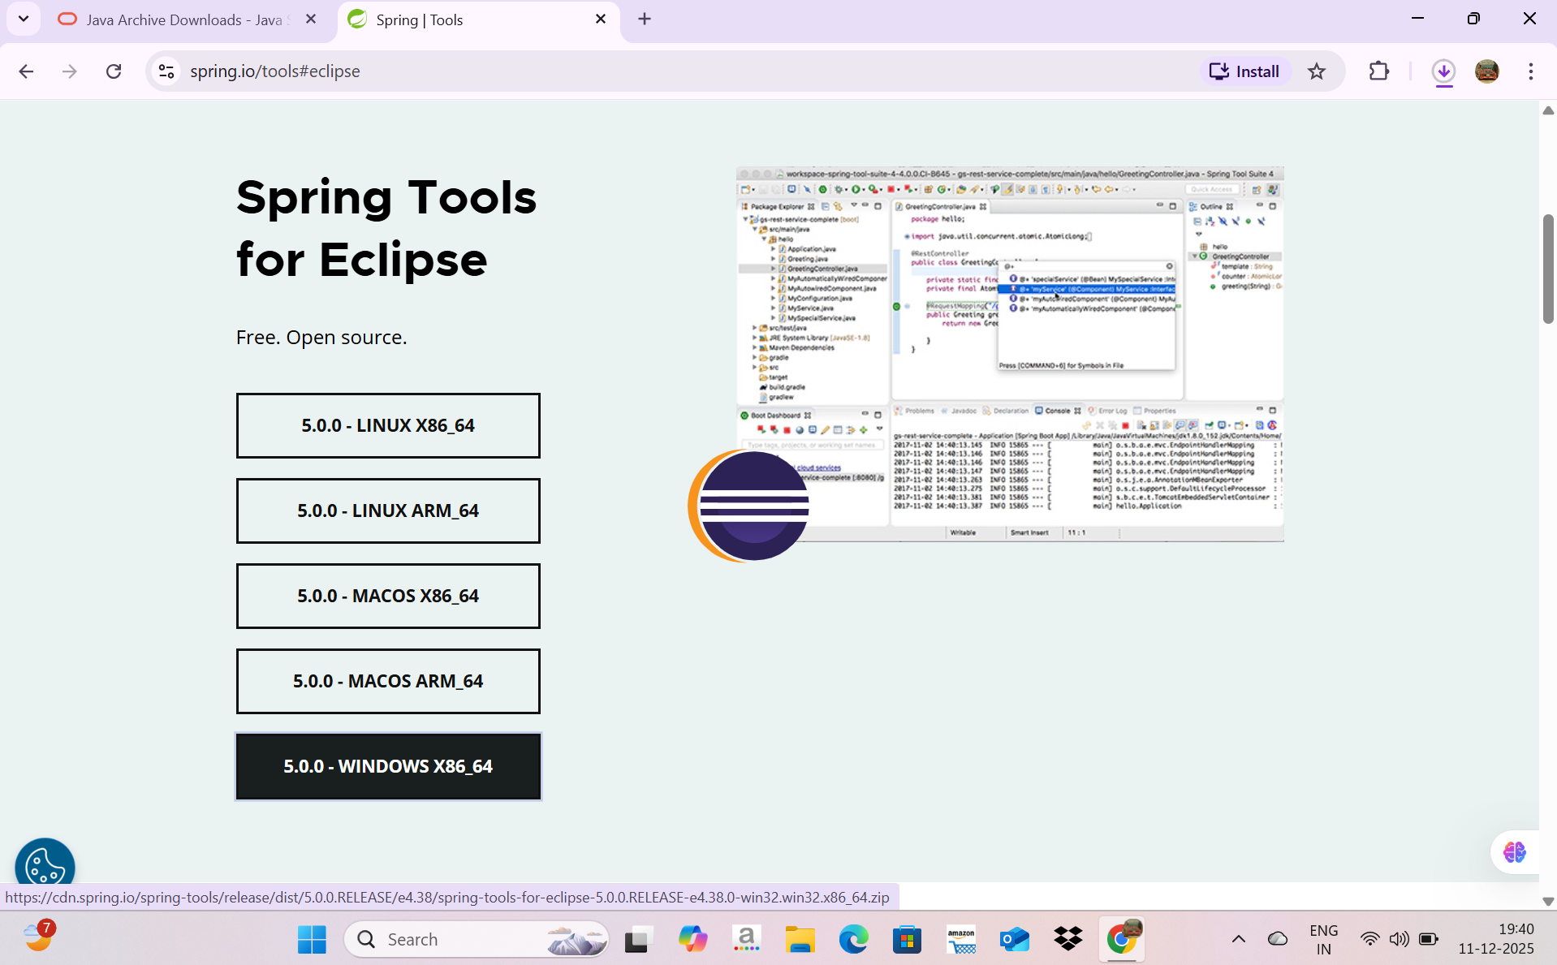

Download
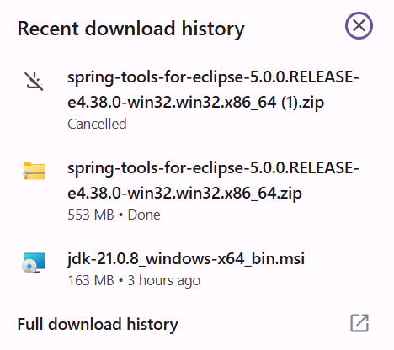

After download open folder where it got downloaded

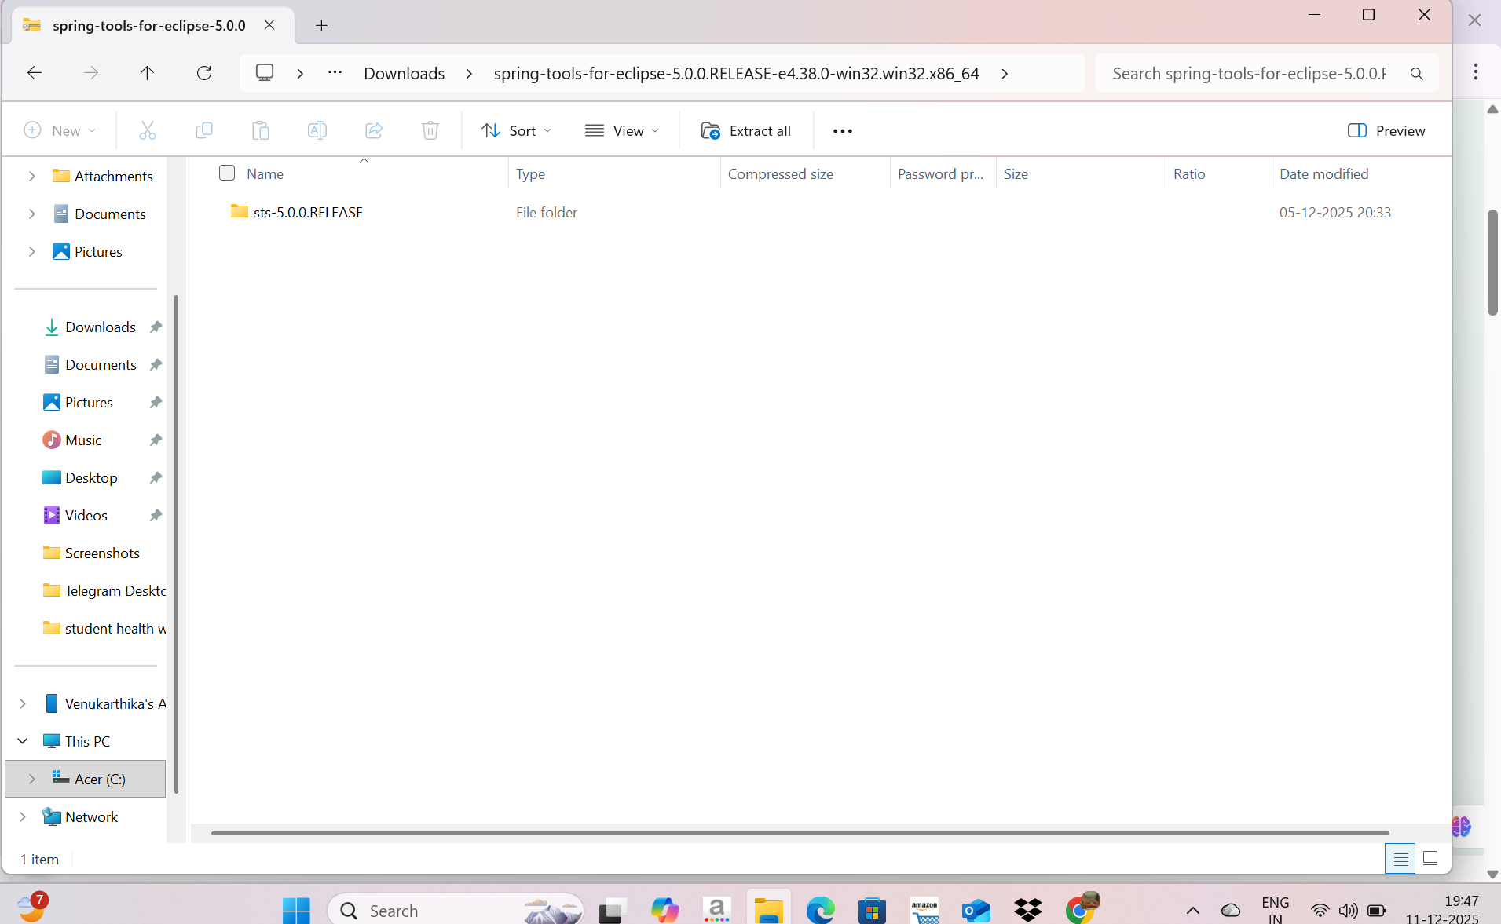
Then click extract all option
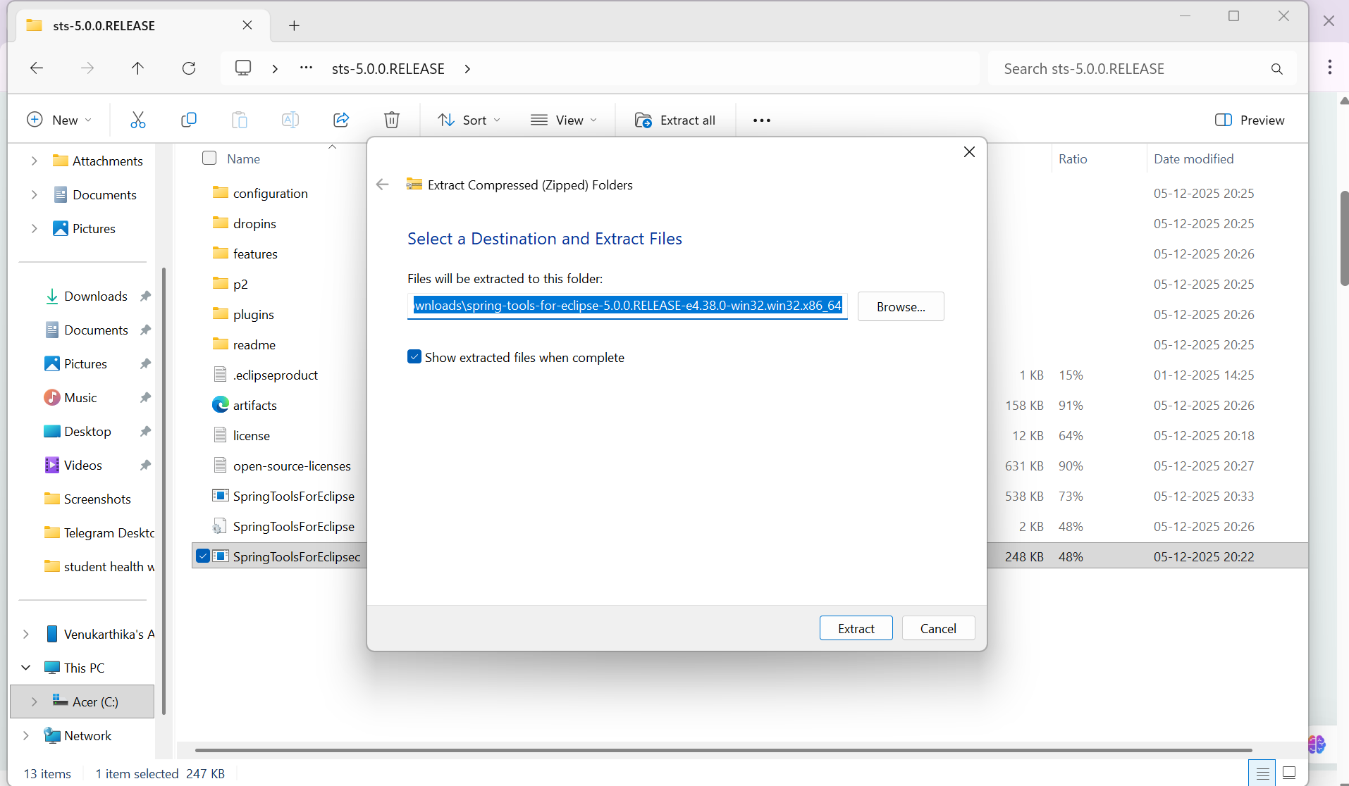
Click browse button
And choose location : C:\Windows

Windows C:\Spring
Make a new folder Spring

And Extract all files
Finally you get
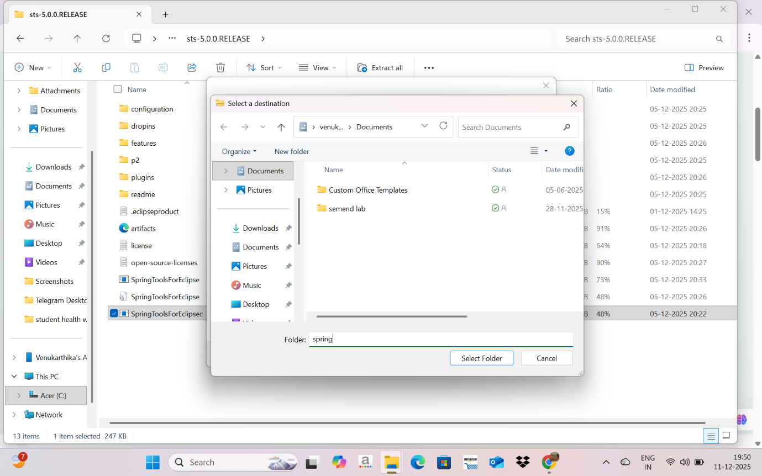
Create “Projects” folder and add that as workspace folder by clicking “Select Folder button”

Click launch

\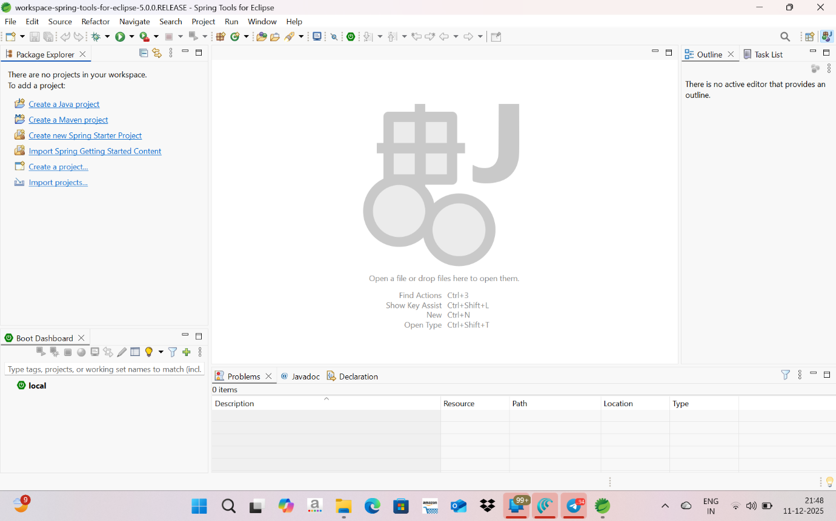

Create “Projects” folder and add that as workspace folder by clicking “Select Folder button”

Click launch

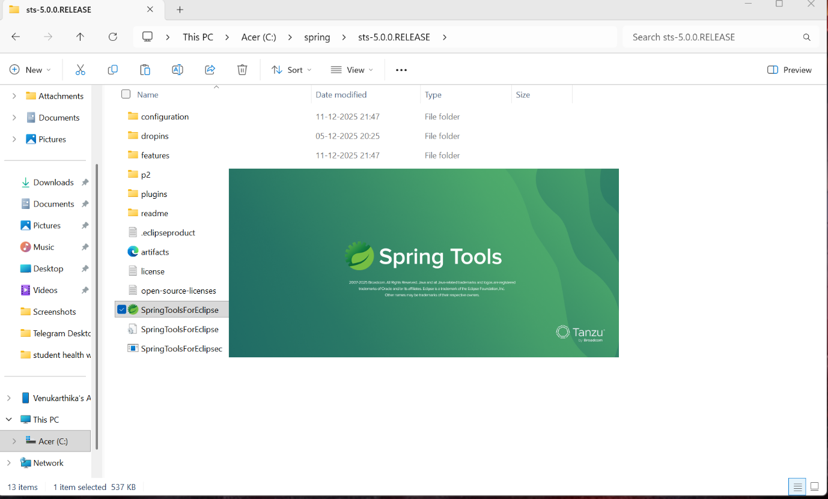

Installation Completed Successfully

